Monday Plan - 11th May 2020

Daily activities:
Spellings: Learn 4 spellings each day.
Reading: Read for at least 20 minutes.
Tables: Practice your multiplication tables (focus on x11 and x12 this week)
Gaeilge: Practice 5 questions of your choice and answer orally.
Whole-school event: Go to the Well-being Fortnight page for today’s activity!

1. English:
Just like every week, we are starting with some stations today. Spend approximately 10 minutes on each task.
- Station 1: Cursive handwriting - complete the handwriting sheet provided. You can print the sheet, or write the passage into your copy. Remember, you can go to Aisling’s page on our website, where she has made a video which shows you how to form each letter in both lower case and upper case.
- Station 2: Spellings - Practice writing out your sixteen new spellings using Look, say, cover, write, check. Look up any unfamiliar words.
- Station 3: Grammar games – Go to Topmarks.com to try some grammar games.
- Station 4: Seesaw activity – complete the assigned activity, based on persuasive writing.

2. Maths:
This week, we will be learning more about division.
*Remember: when we say divide, we mean to share something equally.
- Play ‘Division Facts’ on ‘Hit the Button’.
- Read the ‘Division Recap’ powerpoint presentation.
- Look at / do Planet Maths p.143

3. Gaeilge:
- Watch the video to play Déir Ó Grádaigh (Simon Says) with Aisling. See if you can make it to the end!
- Póstaer 17: Lá sa Pháirc: Listen to and understand the “Scéal” (story) activity
- Póstaer 17: Lá sa Pháirc: complete the “Foclóir” (vocabulary) activity.
(Please see the attached Gaeilge support document for relevant translations)

Bonus Activity: Perhaps you could choose something to draw from this channel. Lots of great activities, teaching you how to draw and create some lovely pictures!

English:
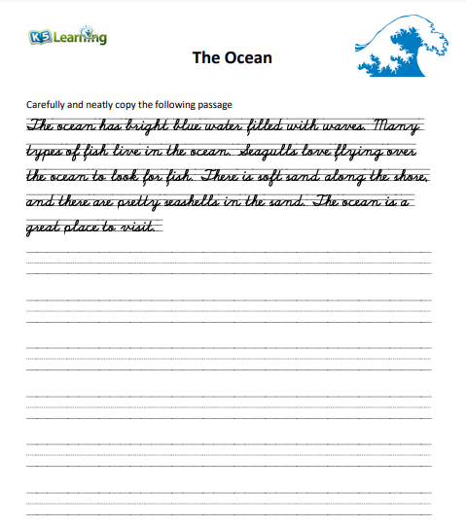

Maths:
