Monday Plan - 18th May 2020

Daily activities:
Spellings: Learn 4 spellings each day.
Reading: Read for at least 20 minutes.
Tables: Practice your division tables (focus on ÷1 and ÷2 this week)
Gaeilge: Practice 5 questions of your choice and answer orally.
Whole-school event: Go to the Language page for today’s activity!

1. English:
Just like every week, we are starting with some stations today. Spend approximately 10 minutes on each task.
- Station 1: Cursive handwriting - complete the handwriting sheet provided. You can print the sheet, or write the passage into your copy. Remember, you can go to Aisling’s page on our website, where she has made a video which shows you how to form each letter in both lower case and upper case.
- Station 2: Spellings - Practice writing out your sixteen new spellings using Look, say, cover, write, check. Look up any unfamiliar words.
- Station 3: Sentences: Put your spellings for this week into sentences.
- Station 4: Grammar games – Go to Topmarks.com to try some grammar games.

2. Maths:
This week, you will be learning all about 3D shapes and their properties. Today’s work is about looking at the shapes, finding examples and learning shape names.
- Look at the table of shapes below. Explore your home or outside, and find at least 2 objects that are the same shape, and write or draw them into the table.
- Look at/do page 152 of your maths book.

3. Gaeilge:
This week, we are continuing our learning on Caitheamh Aimsire (pastimes). Each day, you will be working on your reading, writing, listening and speaking skills and you will have a few short tasks to complete. For any copy work you have to do, remember to take a photo of it and send it to your teacher on Seesaw, where the rest of the activities will be assigned.
- Task 1 on Seesaw: Watch the video to revise the vocabulary with Orla.
- Task 2 on Seesaw: Using your learning from the video, see if you can rearrange the sentences into the correct order.
- Task 3: Written task. Write the 6 sentences from this activity into your copy, once you have them in the correct order. Your title can be ‘Caitheamh Aimsire’. You can take a photo of this and send it to your teacher also!
- Task 4: Read and listen to the poem ‘Ceolchoirm sa Chró’. This is on our class web page.

Bonus activity: It’s really important to stay active while you are at home. Check out a PE lesson with The Body Coach here. It’s a great way to start a new week!

English:
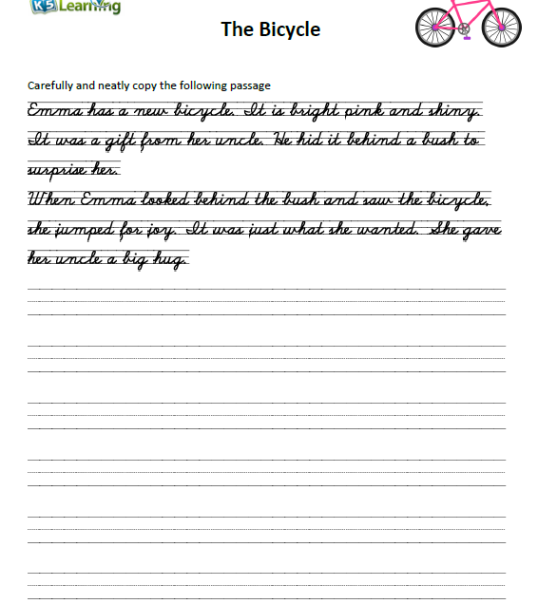

Maths:
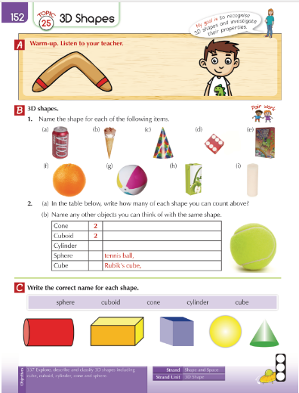

Maths:

Shape | Objects
Cube  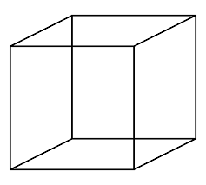 | Rubik’s cube
Cuboid
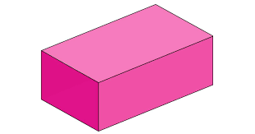
Sphere
Cylinder
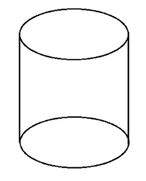
Cone
