Wednesday 20th of May

Word families: Today we will look at the -ug word family. Look at the pictures below and write a list of the words that you see. Remember they all end in -ug. Tomorrow your task will be to write the words without the pictures so make sure you really focus your brain on the pictures that you see and the words that you write.

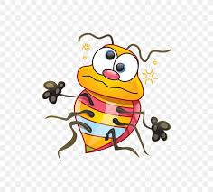 | 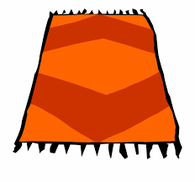
 | 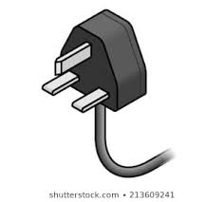 | Can you write some other words that are in the -ug word family?

Oral Language: Head over to SeeSaw to access today’s oral language lesson.
Gaeilge: Watch the video of Sinead on Seesaw.
She will need your help to make an outfit for Podge to wear to the park. Listen carefully to her instructions and draw an outfit for Podge.
Show us your drawing of Podge’s outfit on Seesaw.
Maths:Your Maths work for today is on Seesaw. You will be learning about comparing different amounts of money.

Mother Language Fortnight:
What are you thankful for today?

