Tuesday Plan - 19th May 2020

Daily activities:
Spellings: Learn 4 spellings each day.
Reading: Read for at least 20 minutes.
Tables: Practice your division tables (focus on ÷1 and ÷2 this week)
Gaeilge: Practice 5 questions of your choice and answer orally.
Whole-school event: Go to the Language page for today’s activity!

1. English:
- Today, we will be learning more about homophones. Read through the ‘Are or Our’ powerpoint. Remember:
‘Are’ is a verb: ‘You are doing great work at home.’
‘Our’ is a possessive determiner: ‘Our school is in Citywest.’
- Rewrite the sentences on the ‘Are or Our?’ worksheet, using the correct word. You can then write two of your own sentences - one containing ‘are’ and one containing ‘our.’

2. Maths:
- Today, you will be learning about the different properties of shapes.
- To start, try this game to revise the different 3D shapes.
- Look at and listen to the powerpoint by Aisling, to learn more about the 3D shapes.
- Look at/do page 153 of Planet Maths.

3. Gaeilge:
- Task 1 on Seesaw: Watch the video to continue to revise the vocabulary and phrases.
- Task 2 on Seesaw: Líon na bearnaí. Fill in the blanks from the sentences, based on what pastimes you like/dislike.
- Task 3: Written task. Once you have filled in each sentence on Seesaw, write them into your copy. Remember you can send a photo of your work to your teacher.
- Task 4: Read and listen to the poem ‘Ceolchoirm sa Chró’.

Bonus activity: This week, you will be learning about life in Medieval towns. There is a great exhibition in Dublin City Centre called ‘Dublinia’. They have some great online resources for primary schools. Check out this really interesting map that shows the development of Dublin over time. They also have some really interesting videos about the buildings in Medieval Dublin.

English:
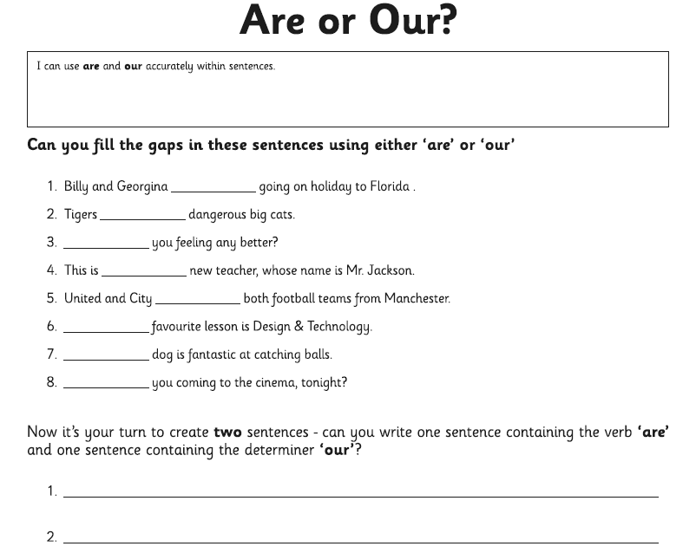

Maths:
