Wednesday Plan
Daily activities:
Spellings: Learn 4 spellings each day.
Reading: Read for at least 20 minutes.
Tables: Practice your multiplication tables (focus on x7 and x8 this week)
Dán: Practice the poem ‘Bláthanna’ (Flowers). Read the poem provided, or listen to our recording of it to help you.

- English: Today we are going to be doing dictation. Listen to Sarah in the video below. She will say ten sentences and you will need to write them down. She will repeat each one once, but feel free to pause the video if you need to. You will need to remember:
- Correct spellings
- Capital letters and punctuation (full stops, commas, question marks, exclamation marks)
- Homophones (e.g. your / you’re, their / they’re / there)
- Irregular past tense verbs (e.g. the past tense of buy is bought)
- Contractions (e.g. would have - would’ve)

2. Maths:
- Play this game to recap on symmetry. Try the ‘Patterns’ option for today to make it a bit trickier!
- Watch this video about lines of symmetry. In your copy, draw 2 shapes/objects which have only one line of symmetry and 2 shapes/objects which have more than one line of symmetry.
- Look at/do p. 135 in Planet Maths.

3. Science:
- Read page 52 and 53 to understand how different instruments make different sounds.
- Answer the questions on page 53 in your copy, by copying the grid and filling in your answers.
- Think about your favourite song or type of music, and make a list of the instruments and sounds you can hear.
- Follow the instructions in this video to make a xylophone out of water and glasses https://www.youtube.com/watch?v=sIO-JhMvu6M

4. Learn Together:
- Today, you are going to create a simple fact file about Sikhism, to recap some of your learning. Be sure to include:
- 3 of the main beliefs of Sikhism
- The 5 Ks of Sikhism
- The building where Sikhs worship and how to show respect here
- The symbol of Sikhism
- The holy book for Sikhs

Bonus activity: Well-known Irish artist Don Conroy has started up his own YouTube channel to teach children how to draw. Check it out here and try to copy one of his drawings!

English - Dictation Exercise:
(Listen to Sarah’s recording first and then use this document to correct your work!)

Answers:
- Their coats, shoes and hats are over there.
- “I should’ve done my homework,” said the child.
- Anna is going to Cork on Saturday.
- “You’re wearing your new shoes,” said granny.
- I went to Tesco and I bought milk, butter, eggs and bread.
- “Can I see your work please?” asked the teacher.
- Citywest is a suburb in Dublin.
- I thought that it was a good idea.
- “We won our match!” shouted John.
- We couldn’t go out to yard because it was icy.

Maths:
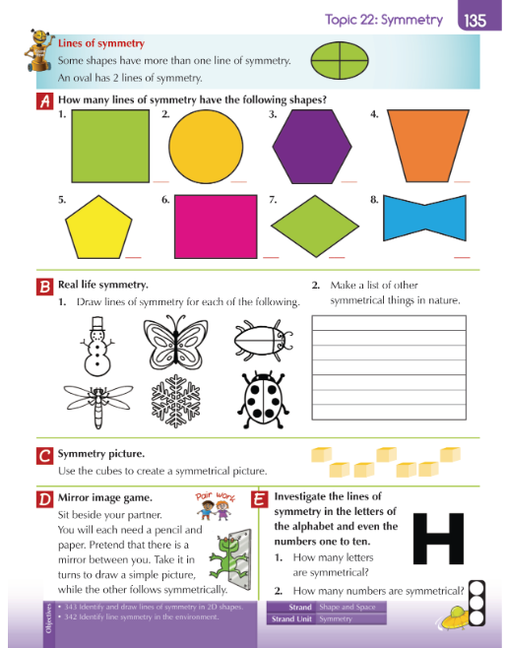

Science:
