Tuesday:
Daily Activities
Morning Meeting: Check out Seesaw each morning!
​Spellings: Learn spellings daily.
Writing: Set a timer for 5 minutes and do some "free writing" or "free typing" on a topic of your choice.
Reading: Try to read for at least 15 minutes (or more if you can)!
Maths: Daily 10 Mental Maths Questions. Try level 1 or 2.
Skip counting: in 4s backwards from 40. (40, 36, 32, 28, 24, 20, 16, 12, 8, 4, 0)
Tables: Practice -6 tables.
Whole-school event: *Find the link for Diversity Fortnight on the home page
1. English:
(These activities are also available to complete on Seesaw)
Spellings.
Find the list below.
This week most of your spellings make an /u/ sound.
- Underline the /u/ sound in 6 of these words.
- They are spelt with <o>.
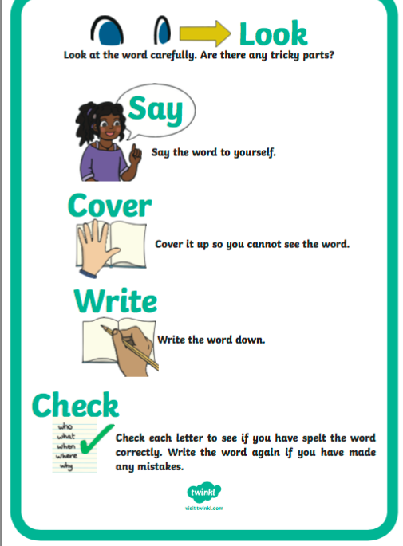
- Learn the first 4 spellings (clever, woman, women, gloves). Remember to use the “Look, Say, Cover, Write, Check” method. See poster here.

Spelling List:
clever
woman
women
gloves
front
dozen
monkey
somebody

Writing.

- Choose 6 words from the spelling list and write them in an interesting sentence. You will have 6 sentences in total.
Check each sentence. Make sure that it makes sense and that you have a capital letter, finger spaces and full stops.

Maths

- Today we are looking at subtraction.
- Subtraction means that we are taking something away.
- Try these quick mental maths subtraction activities in your head just to get you warmed up, no need to write them down!
- 17-8=
- 22-10=
- 15-9=
- 35-8=
- 50-7=
- Remember, we always start on the units first!
- Complete the worksheet below on Subtraction. No need to print the worksheet, just write the sums in your copy or a piece of paper.
*Challenge- Open the resource titled ‘Maths challenge 1’’ and complete Monday andTuesday.

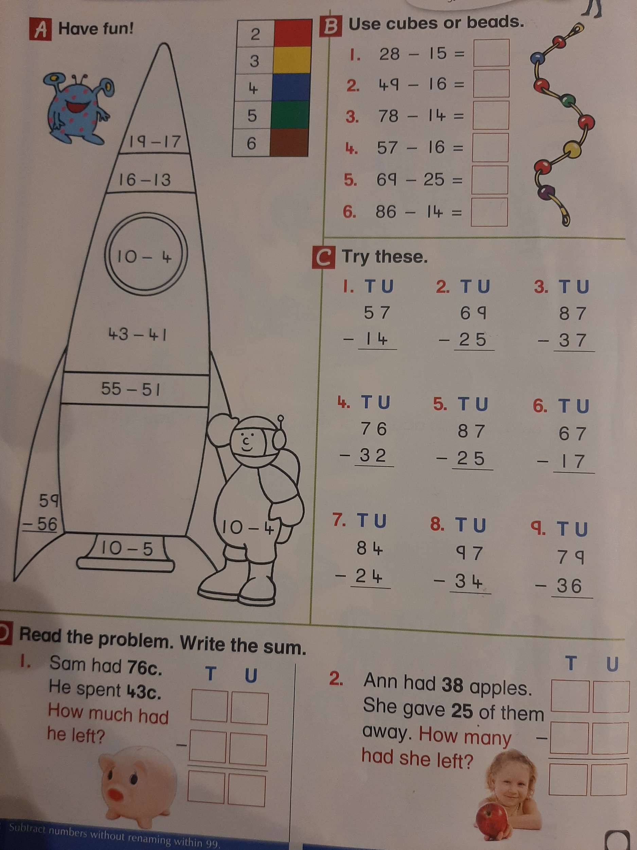

SESE: Sun Safety

- We are going to look at Sun safety this week. I know so many of you will find this very interesting and fun.
- It will also explain how important it is to protect yourself from the Sun. Enjoy!
- Open the resource titled ‘Sun safety’ on the homepage.
- Read through the powerpoint and answer the following questions in a copy or a piece of paper. Remember to use full sentences.
- What type of energy does the sun give off?
- Why do we need to protect our skin from the Sun?
- Name 3 ways that we can enjoy the Sun whilst staying safe too.
- At what times is the sun at its strongest?

Check each sentence. Make sure that it makes sense and that you have a capital letter, finger spaces and a full stop.

