Friday:
Daily Activities
Morning Meeting: Check out Seesaw each morning!
​Spellings: Learn spellings daily.
Writing: Set a timer for 5 minutes and do some "free writing" or "free typing" on a topic of your choice.
Reading: Try to read for at least 15 minutes (or more if you can)!
Maths: Daily 10 Mental Maths Questions. Try level 1 or 2.
.Skip counting: in 3s backwards from 30. (30, 27, 24, 21, 18, 15, 12, 9, 6, 3, 0)
Tables: Practice -5 tables.
Whole-school event: Go to the Mother Language and Multi-Language Fortnight page for today’s activity.

1. Tests:
- Spellings: ask an adult to test you on your spellings for this week.
Adults- please call out each spelling and ask your child to write their answer. Go through corrections together.
- Maths: ask an adult to test you on your -5 times table. Write down your answers and have an adult check them for you. Go through corrections together.
*Note for adults: Ask your child to write out and answer ten “-5 “ sums.
E.g. 10-5= ?, 11-5= ?
Please do not go beyond 20-5= ? (unless your child is fully confident with that).

2. English.
Writing.
Today we will practice some cursive writing.
Check out Seesaw for this lesson.

*Challenge. Write a short story based on a topic of your choice. Practice your cursive writing skills!
Some titles you can choose from if you can’t think of one yourself:
‘The Tall Oak Tree’, ‘The Crazy Clown’, ‘The Unhappy Sun’.

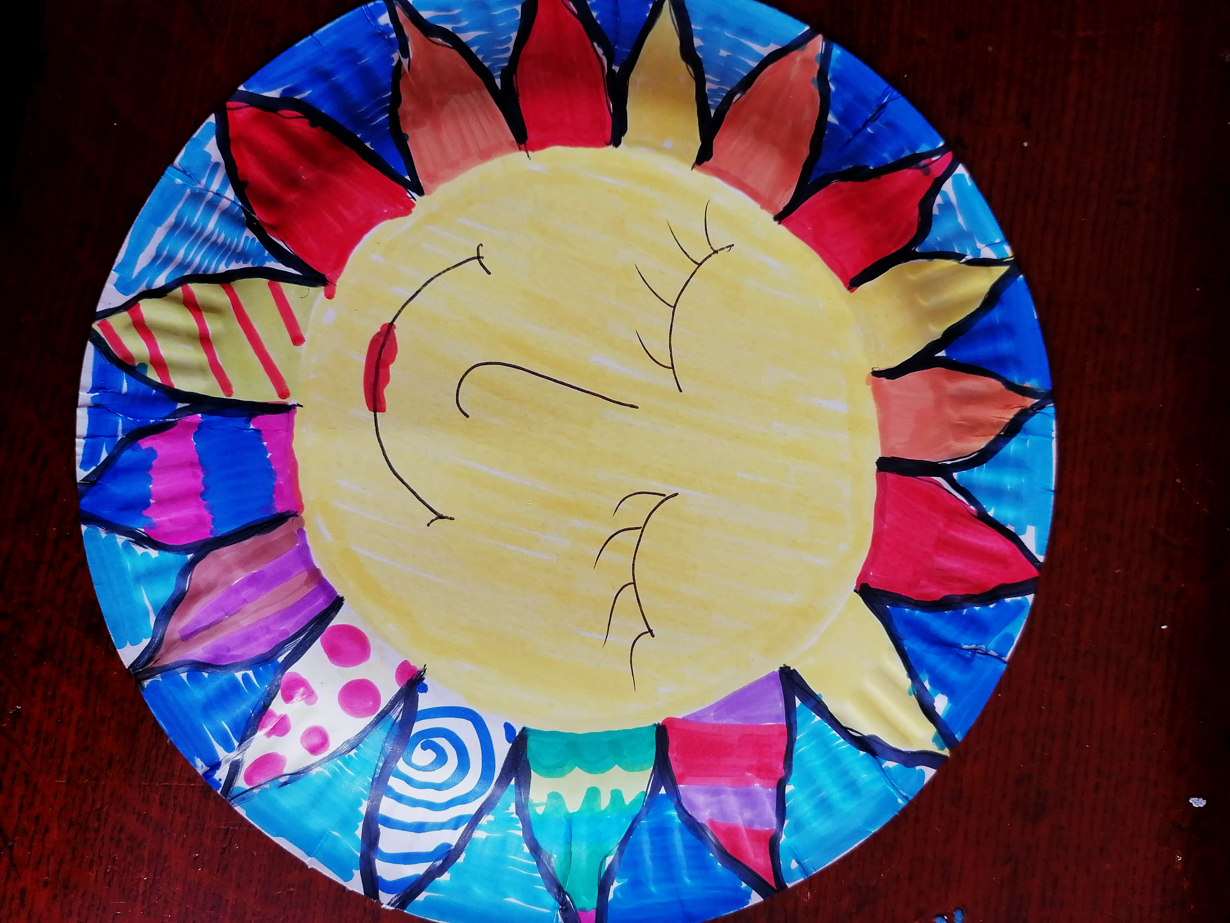
3. SESE/Art.
This week you have been learning all about the sun. Now we are going to some arts and crafts based on the sun.

In your book pack you should have received a paper plate. You can use it for this activity.

Log in to Seesaw to watch a video on how to create this sun.

2. Maths: Addition

- Today we are looking at the topic of addition.
- Remember, addition is adding something to something else.
- During addition sums, we have tens and units. We always start with the units!
- Just like yesterday, we are going to have some fun with problem solving activities today.
- And there is a fun game at the bottom of the worksheet that you can play if you have 2 dice!
- Here are some examples that you can do just to get warmed up! Use a copy or a piece of paper to help you.
- There are 52 white keys and 36 black keys on a piano. How many keys are there altogether?
- There are 3 buses on their way to Dublin. There were 36 people on a bus from Cork, 28 people on a bus from Belfast and 16 people on a bus from Mayo. How many people were travelling to Dublin altogether?

- Complete the worksheet below on addition. No need to print the worksheet, just write the answers in your copy or a piece of paper.
*Challenge- Open the resource titled ‘Maths challenge 1’ and complete Friday

