Thursday:
Daily Activities
​Morning Meeting
Spellings: Learn spellings daily.
Writing: Set a timer for 5 minutes
and do some "free writing" or "free typing" on a topic of
your choice.
Reading: Try to read for at least 15
minutes (or more if you can)!
Maths: Daily 10 Mental Maths Questions. Try level 1 or 2.
Skip counting: in 10s. (10, 20, 30, 40, 50,
60, 70, 80, 90. 100)
Tables: Practice 9+ tables.
Whole-school event: Go to the Well-being Fortnight page for today’s activity.

1. English:
Spellings.
Practise spelling your words for your test tomorrow.

Writing.
Visit the Seesaw app for today’s activity. Enjoy using this new way of learning! :)

2. Maths:
- Today we are doing some problem solving activities on place value.
- Problem solving activities are fun because we get to read and do maths!
- Here are 3 problems. Write the answer in your copy or on a piece of paper.
- Mary went to the shop and bought 30 sweets. How many tens could she make with the 30 sweets?
- John went to a fruit market and bought 46 apples? How many tens and how many units did he have?
- Lisa counted 125 trees in a forest. How many hundred how many tens and how many units did she count?
- Now, complete the worksheet below, read it carefully and slowly!
*Challenge- Open the resource titled ‘Maths challenge 2’ and complete Thursday.
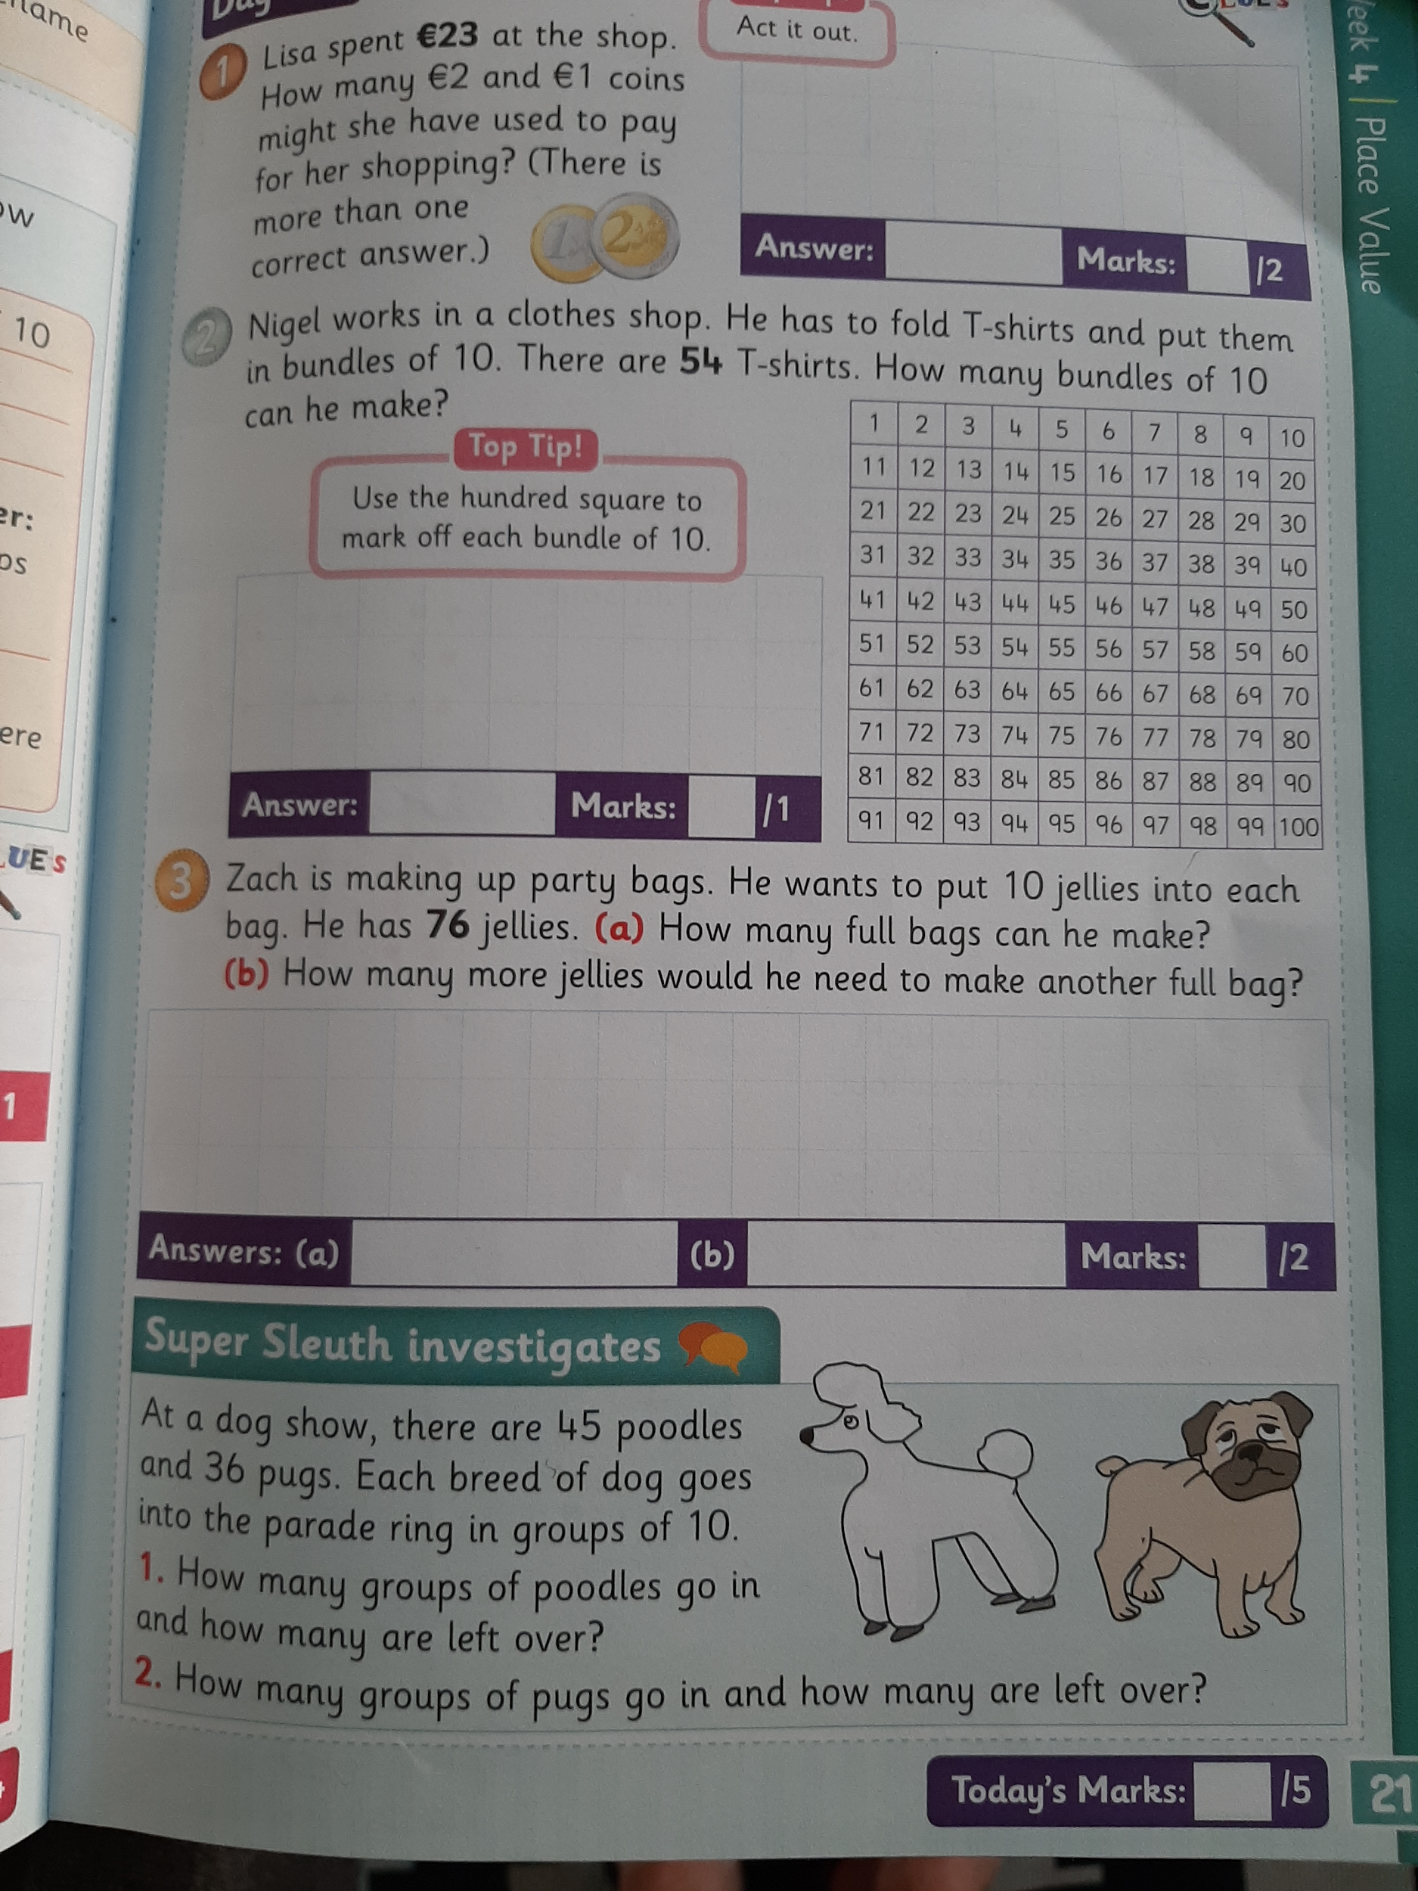
4. Gaeilge
Look back on this week’s Home Learning page and click on the resources titled
Cé mhéad? - Watch video
Ceacht 3 - Watch video

Give the Gaeilge activity sheet below a try!
