Tuesday:
Daily Activities
Morning Meeting
​Spellings: Learn spellings daily.
Writing: Set a timer for 5 minutes
and do some "free writing" or "free typing" on a topic of
your choice.
Reading: Try to read for at least 15
minutes (or more if you can)!
Maths: Daily 10 Mental Maths Questions. Try level 1 or 2.
Skip counting: in 10s. (10, 20, 30, 40, 50,
60, 70, 80, 90, 100)
Tables: Practice 9+ tables.
Whole-school event: Go to the Well-being Fortnight page for today’s activity.

1. English:
Spellings
- Learn the next 3 spellings - fiction, action, minute.
Remember your spelling strategy: “Look, Say, Cover, Write, Check”

Writing
- Complete the worksheet below.
-Part 1. Write some <ti> words in the dictionary on part 1 of the worksheet.
-Part 2. Fill in the blanks with words from your spelling list.
-Part 3. Last week we learned that apostrophe <s> shows that something belongs to someone. For example; Daisy’s shoe or Anabelle’s wish. You need to add 2 of these to the piece of writing.

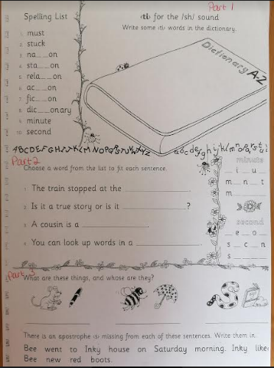

2. Maths:

- Let's look at place value again today, I hope that you enjoyed yesterday's activity in finding the 10s and units.
- Today we will look at finding some missing numbers, the hundred square on the worksheet may help.
- Try these, no need to write them down. Just say them in your head and try to fill in the missing numbers.
- 22, 23, …, 25,
- 41, 42, …, 44, 45, …, 47, .
- 58, 59, …, 61, …, 63, …, 65
- 31, 32, 33, …, …, 36, …, 38
- 64, 65, …, 67, …, 69, ...

- Complete the worksheet below on place value
*Challenge- Open the resource titled ‘Maths challenge 1’ and complete Tuesday

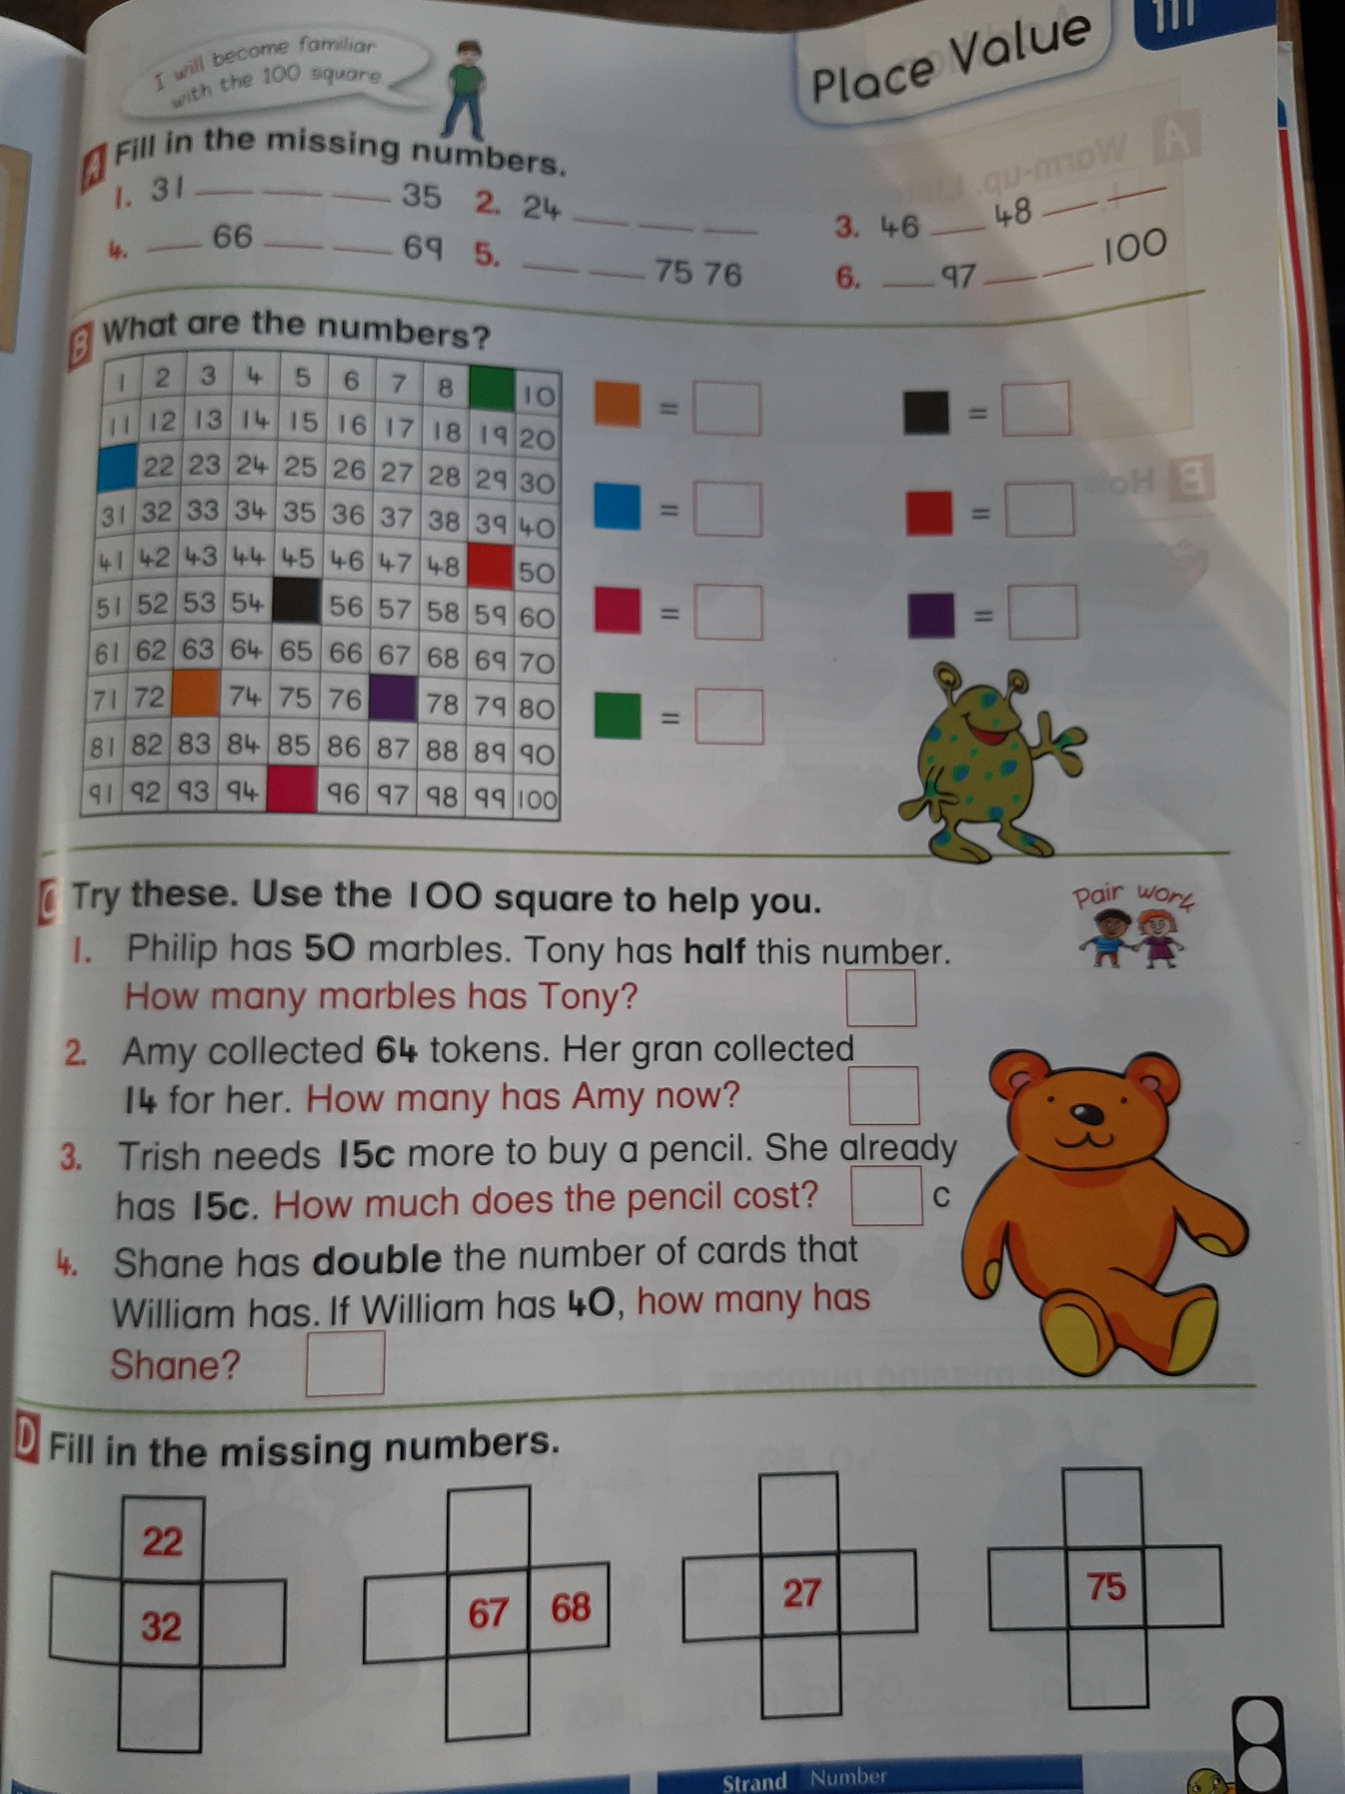

4. Gaeilge
This week we will be looking at a new theme; ‘Siopadóireacht’ which means ‘shopping’.
What comes into your mind when you think of siopadóireacht?

- Look back on this week’s Home Learning page and click on the resources titled
Torthai - Watch video
Ceacht 1 - Watch video

- Complete the activity sheet below.
- You will see in the picture that there are lots of different groceries in the shop. Do you recognise any of these?
- Which of these do you like?
- I remember seeing some of these in lunch boxes.
Then there are questions asking whether the characters bought particular groceries. Have a look at the characters to see what they bought.
Ar cheannaigh? = Did (someone) buy?
Cheannaigh = yes they bought
Níor cheannaigh = no they didn’t buy.

