Tuesday:
Daily Activities
Morning Meeting: Check out Seesaw each morning!
​Spellings: Learn spellings daily.
Writing: Set a timer for 5 minutes and do some "free writing" or "free typing" on a topic of your choice.
Reading: Try to read for at least 15 minutes (or more if you can)!
Maths: Daily 10 Mental Maths Questions. Try level 1 or 2.
.Skip counting: in 3s backwards from 30. (30, 27, 24, 21, 18, 15, 12, 9, 6, 3, 0)
Tables: Practice -5 tables.
Whole-school event: Go to the Mother Language and Multi-Language Fortnight page for today’s activity.

1. English:
Spellings
- Learn the next 3 spellings - eight, eighty, eighteen.
Remember your spelling strategy: “Look, Say, Cover, Write, Check.”

Writing
- Complete worksheet ‘Spelling Sheet 31’.
- Log in to Seesaw to listen to the instructions for this.

2. Maths: Addition

- Today we are looking at the topic of Addition
- Remember, addition is adding something to something else.
- During addition sums, we have tens and units. We always start with the units!
- When we finish the units we often have to carry a number across to the tens.
- Use this rhyme to help you:
  - More than 9? That’s just fine! When you have ten or more, send the ten next door!

For example
T U
4 5
+ 31 9
8 4

We add the units first, carry over the 1 ten and then add the tens!

- Complete the worksheet below on addition. No need to print the worksheet, just write the sums in your copy or a piece of paper.
*Challenge- Open the resource titled ‘Maths challenge 1’ and complete Tuesday

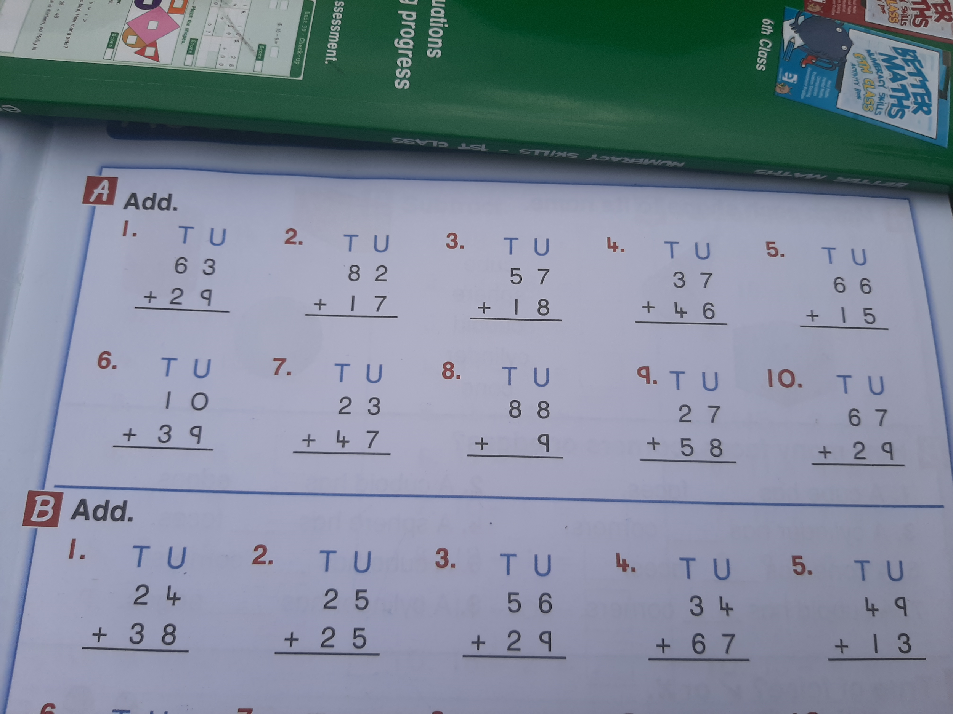

3. SESE: The Sun

- We are going to look at The Sun this week. I know so many of you will find this very interesting and fun!
- Open the resource titled ‘The Sun”’ on the homepage.
- Read the comprehension about The Sun and try to fill in the answers. You can write it in your copy if you like or just read it in your head. When you finish the task you will find the missing answers in the comprehension.

