Monday:
Daily Activities
​Morning Meeting
Spellings: Learn spellings daily.
Writing: Set a timer for 5 minutes
and do some "free writing" or "free typing" on a topic of
your choice.
Reading: Try to read for at least 15
minutes (or more if you can)!
Maths: Daily 10 Mental Maths Questions. Try level 1 or 2.
Skip counting: in 10s. (10, 20, 30, 40, 50, 60, 70, 80, 90, 100)
Tables: Practice 9+ tables.
Whole-school event: Go to the Well-being Fortnight page for today’s activity.

1. English:
Spellings.
Find the list below.
This week most of your spellings have <ti> and make a /sh/ sound.
- Underline the /sh/ sound in 6 of these words.
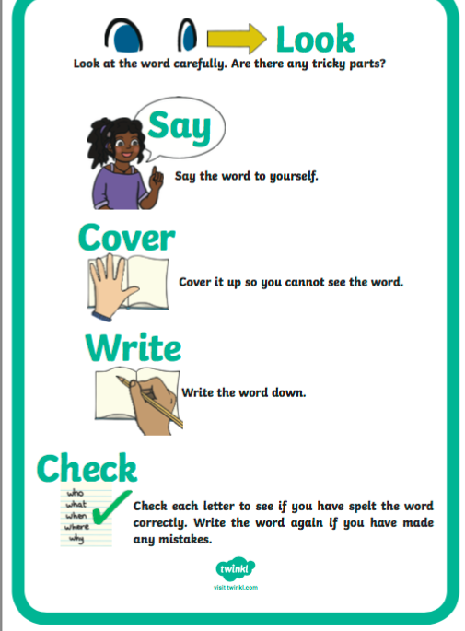
- Learn the first 4 spellings (dictionary, relation, station, nation.).Have a look at the “Look, Say, Cover, Write, Check” poster here.

Spelling List:
dictionary
relation
station
nation
fiction
action
minute
second
must
stuck

Writing.
Choose 6 words from the spelling list and write them in an interesting sentence. You will have 6 sentences in total.
-Check each sentence. Make sure that it makes sense and that you have a capital letter, finger spaces and full stops.

2. Maths:
We are looking at Place Value this week. Place value is the value of a digit depending on its position in the number, such as ones, tens and hundreds places.
Log in to Seesaw app to find a fun place value activity!
- When learning about place value, the number 10 is important.
- 10 is the amount that makes up a ten.
- For example, in the number 16, there is 1 ten and 6 units. In the number 24, there are 2 tens and 4 units. In the number 35 there are 3 tens and 5 units.
- On the worksheet, try the activities on tens and units, it'll be fun!
- Complete the worksheet on Place Value.

*Challenge- Open the resource titled ‘Maths challenge 1’ and complete Monday

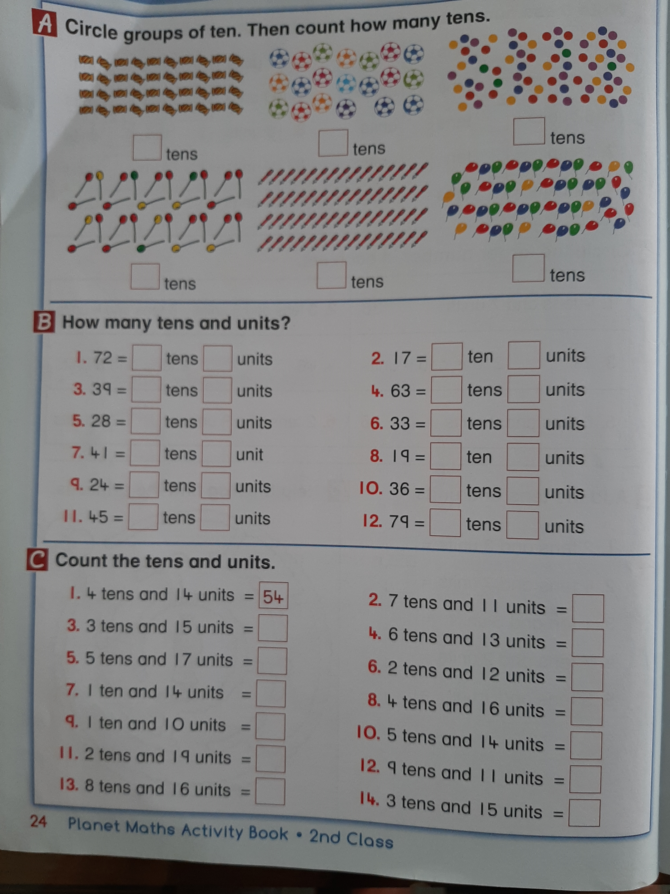

3. SESE
We are going to look at The Burren. Have you ever heard of The Burren before?
The Burren is a region of County Clare in the southwest of Ireland. It’s a karst landscape of bedrock incorporating a vast cracked pavement of glacial-era limestone, with cliffs and caves, fossils, rock formations and archaeological sites.

Open the resource titled ‘The Burren’ on the homepage.
- Write the answers to these questions:
- In what county is the Burren located?
- How does the rock in the Burren get its unusual appearance?
- Where would we find stalactites forming in the Burren?
- How do limestone caves form?
- Where would we find stalagmites forming in the Burren?

Please use full sentences when writing your answers and check for capital letters, finger spaces and full stops.

