Friday

Suggested Daily Schedule

Spellings: learn 6 spellings each day
Maths: Practice Big Maths Beat That each day
Reading: read a book for 30 mins each day
Wellbeing: complete your activity for each day

Bonus Activity-Take a fun book quiz

Friday:
Test: Test yourself on your spellings from the week. (Maybe 10 spellings and 10-15 sums). If you don’t have anyone to help you could test yourself - or why not make a wordsearch or crossword with all of your spellings!
Test yourself on Big Maths Beat that too, see if you can beat your score from Monday!

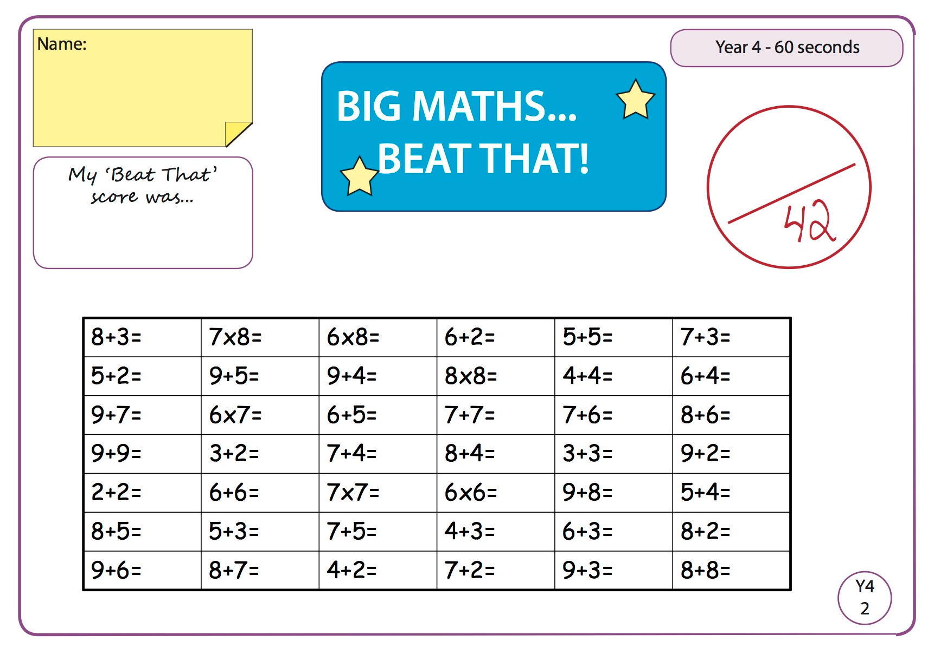

- Maths:
- Create your own number pattern using the worksheet below. Example: for the first one I would start by writing down 5. The rule is to add 2. So my number pattern would be 5,7,9,11, 13, 15. The third number in the sequence is 9.
- (I have included a link to the document which contains the answers and also another similar worksheet if needed, this can be found on the home learning page for this week)

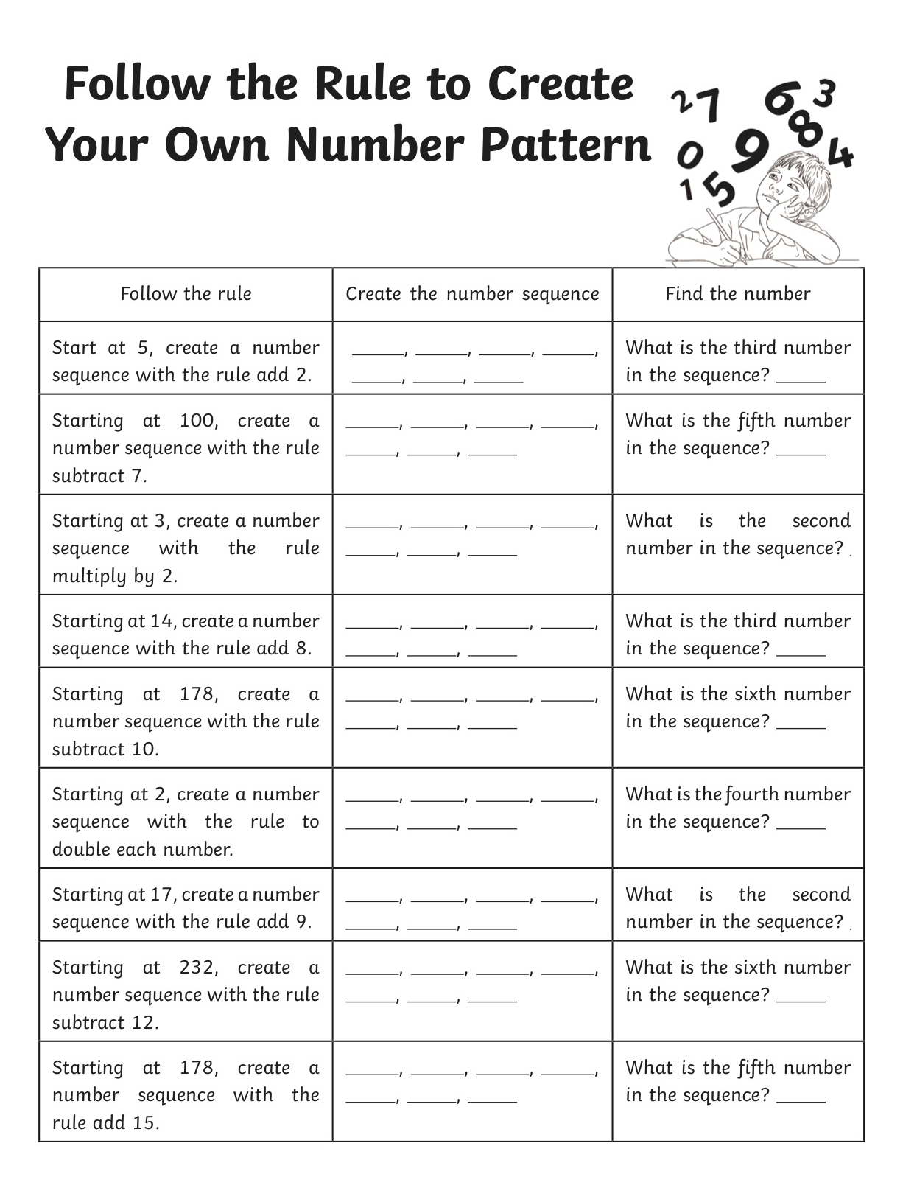

- Gaeilge
Críochnaigh na habairtí. Tá físeán ann chun cabhrú leat. (Finish the sentences. There is a video to help you)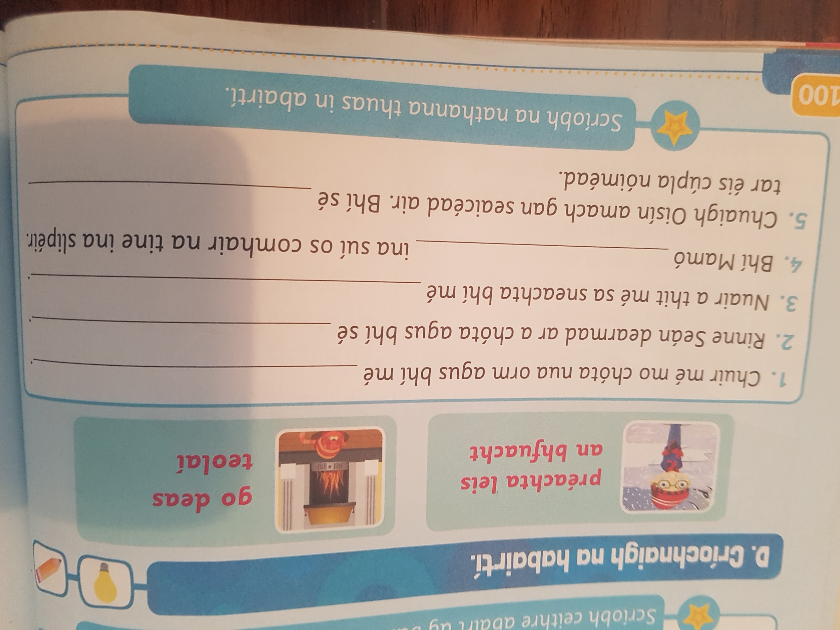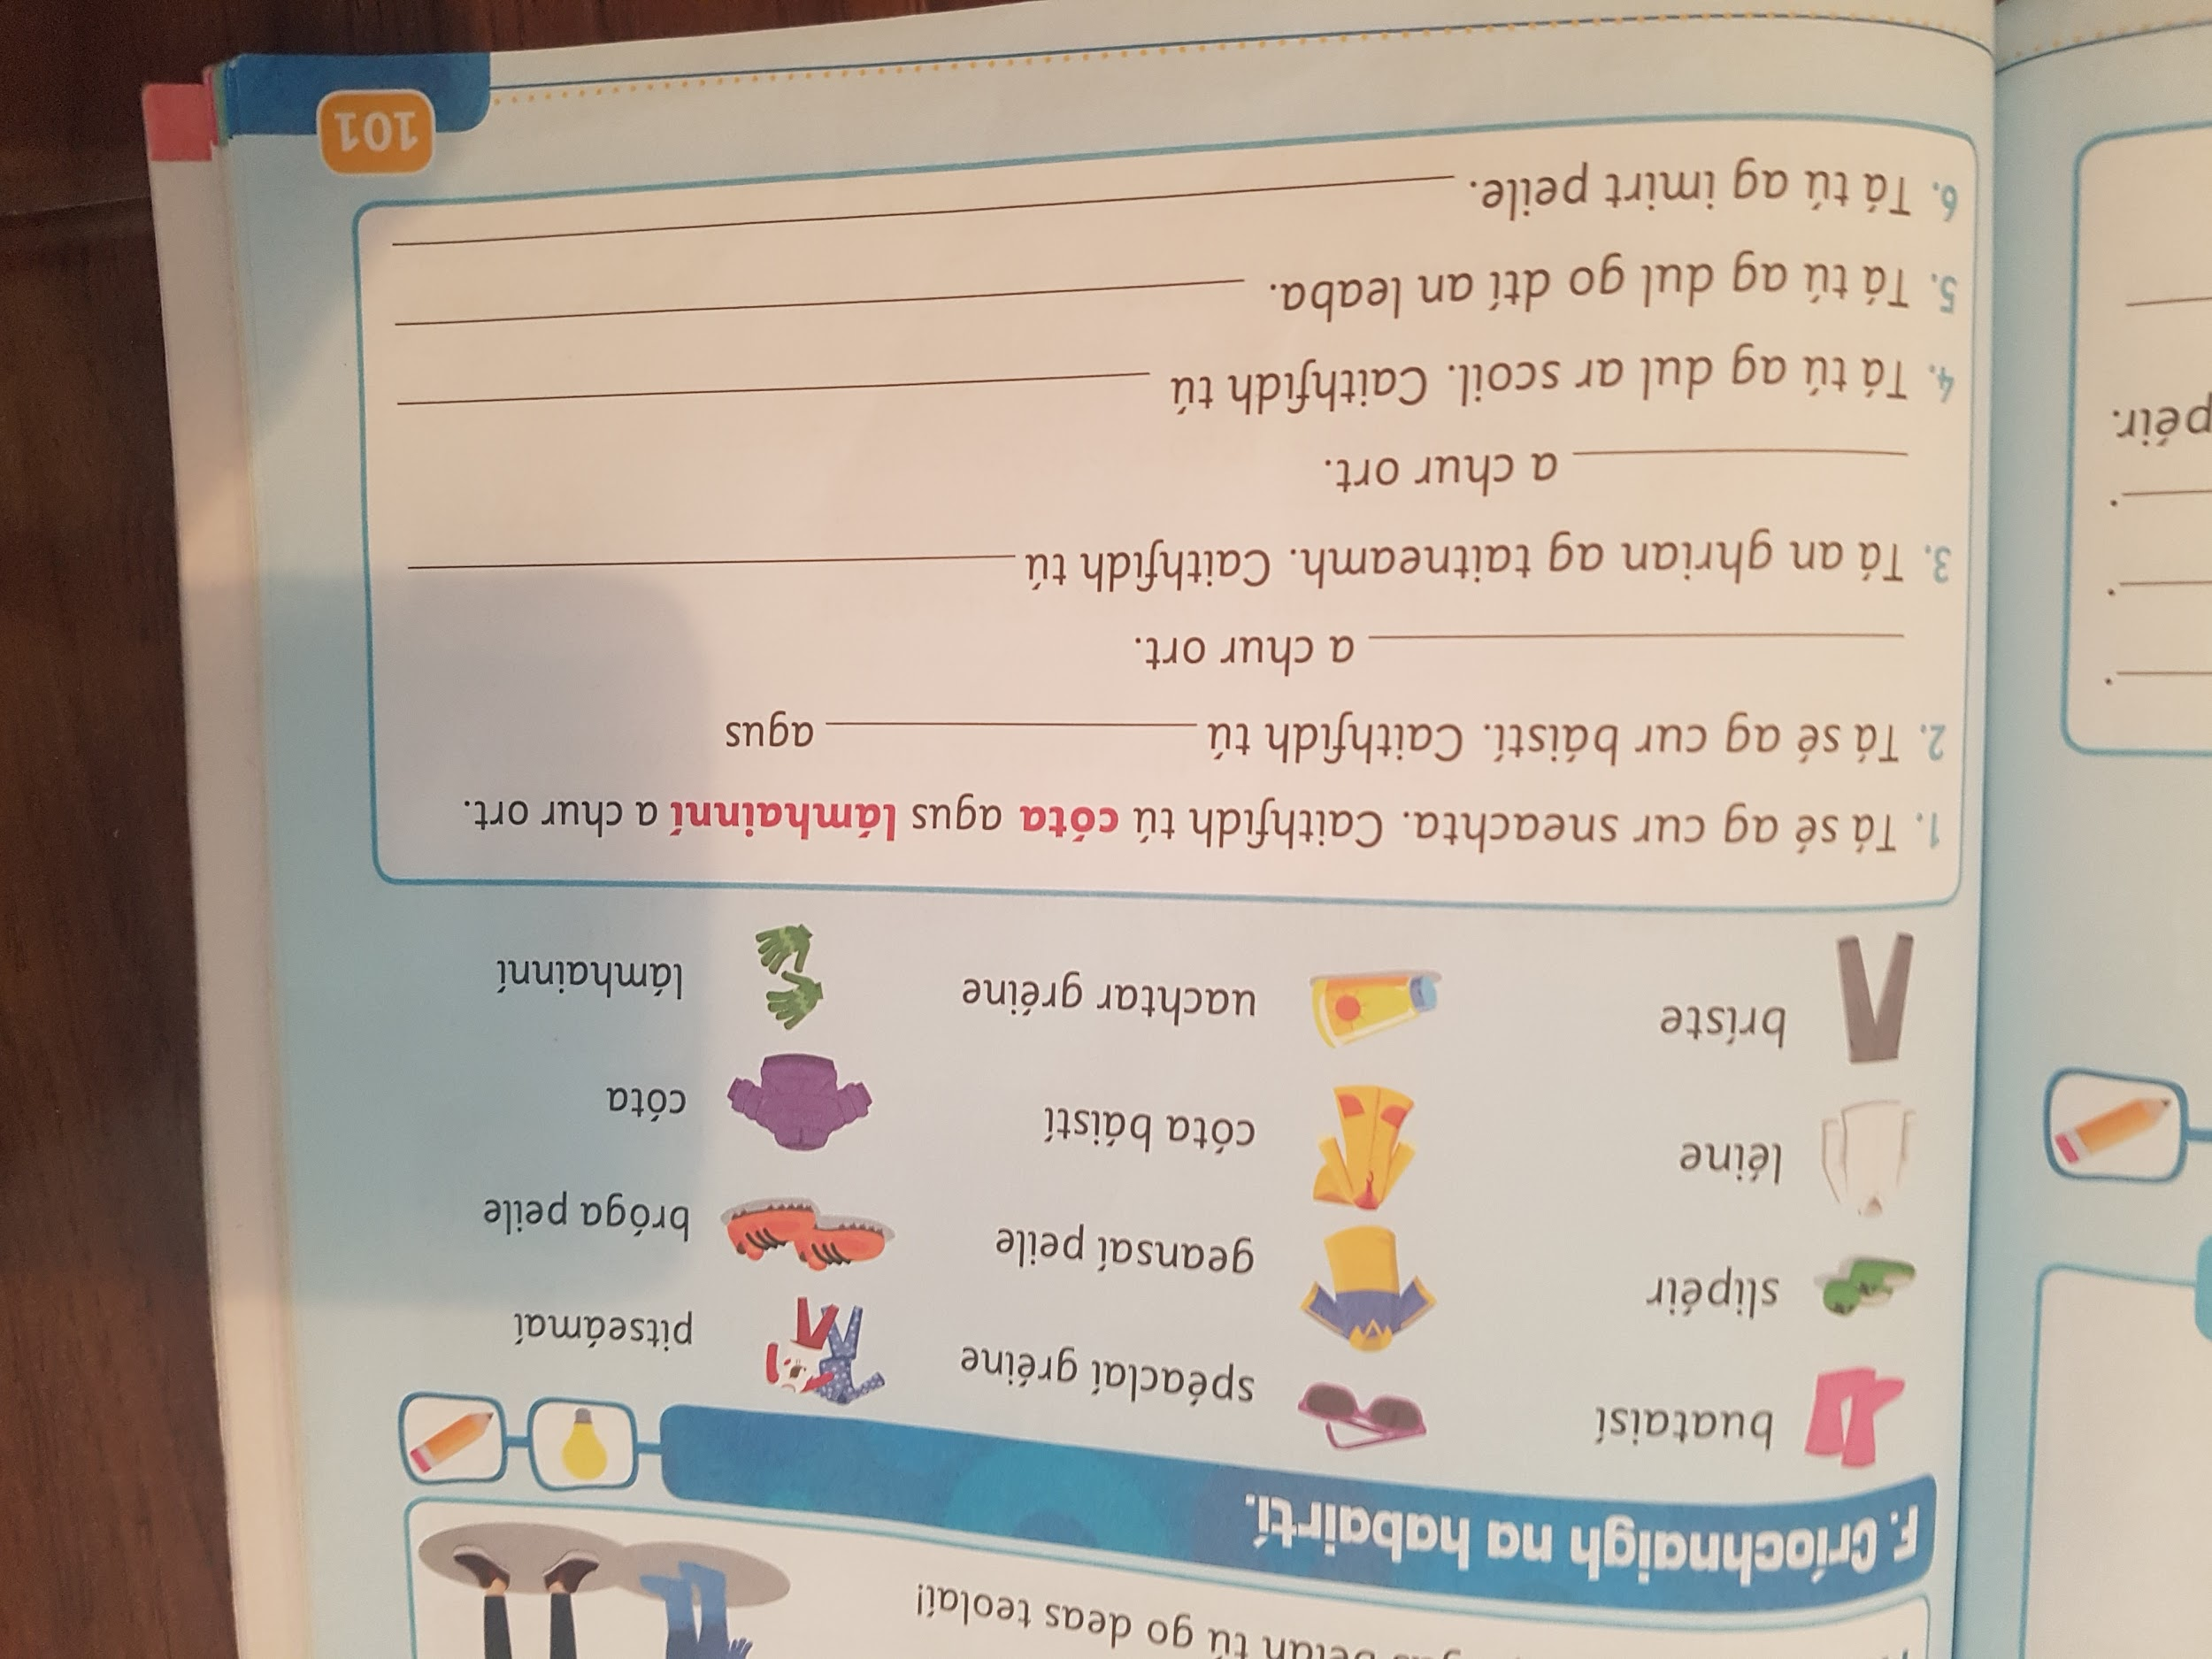
- English
Choose your favourite book or a book that you have just read. Write a recommendation to the students in Citywest ETNS as to why they should read this book. Give at least 3 reasons as to why this book is a great book to read.

You can include some of following titles:
Book name
Author
Genre( fiction, non-fiction, adventure story, animal story etc.)
Character description
Setting description

If you would like you could submit your book to the Citywest ETNS book club.

