Friday:

Daily Activities
​Whole-school event: Go to the Well-being Fortnight page for today’s activity!
Spellings: Learn spellings daily and write 3 of the words in interesting sentences.
Writing: Set a timer for 5 minutes and do some "free writing" or "free typing" on a topic of your choice.
Reading: Try to read for at least 15 minutes (or more if you can)!
Maths: Daily 10 Mental Maths Questions. Try level 1 or 2.
- Skip counting in 5s to 50 (0, 5, 10, 15, 20, 25, 30, 35, 40, 45, 50)
- Weekly tables 8+
8+ Tables

8+0=8
8+1=9
8+2=10
8+3=11
8+4=12
8+5=13
8+6=14
8+7=15
8+8 =16
8+9=17
8+10=18

https://www.topmarks.co.uk/maths-games/hit-the-button. Click the link, go to halves and play halves to 10. Have fun!

1. Tests:
- Spellings: ask an adult to test you on your spellings for this week.
Adults- please call out each spelling and ask your child to write their answer. Go through corrections together.
- Maths: ask an adult to test you on your “add 8” times table. Write down your answers and have an adult check them for you. Go through corrections together.
*Note for adults: Ask your child to write out and answer ten “8+ “ sums.
E.g. 8+5= ?, 8+11= ?
Please do not go beyond 8+20= ? (unless your child is fully confident with that).

2. Maths:
- Let's do a quick recap on 3D shapes.
- Can you remember the sides, corners and edges that each 3D shape has? No need to write them down, just think of them in your head.
- Can you remember which 3D shapes roll, slide and stack? Again, just think of them in your head.
- Today’s activity is on problem solving so I hope you have fun solving them, try your best and enjoy them! There is a game to play too, it’s called “The Great Shape Race” and you will really have fun with it!
- Complete this worksheet on 3D shapes.
*Challenge: complete worksheet marked “Friday review” and the remaining problem-solving questions.

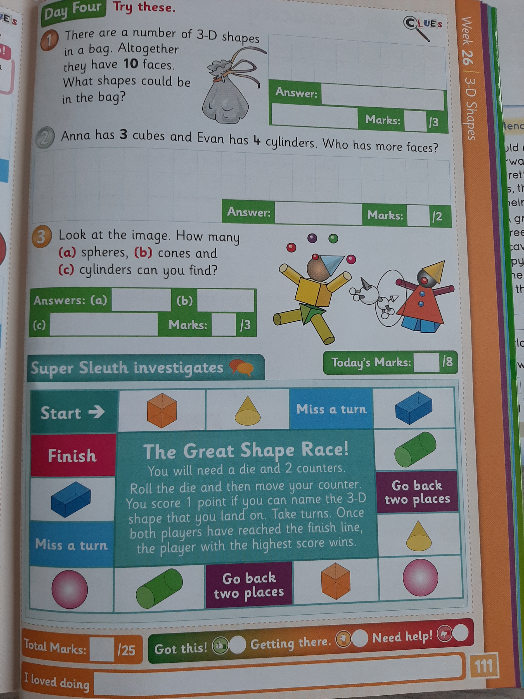
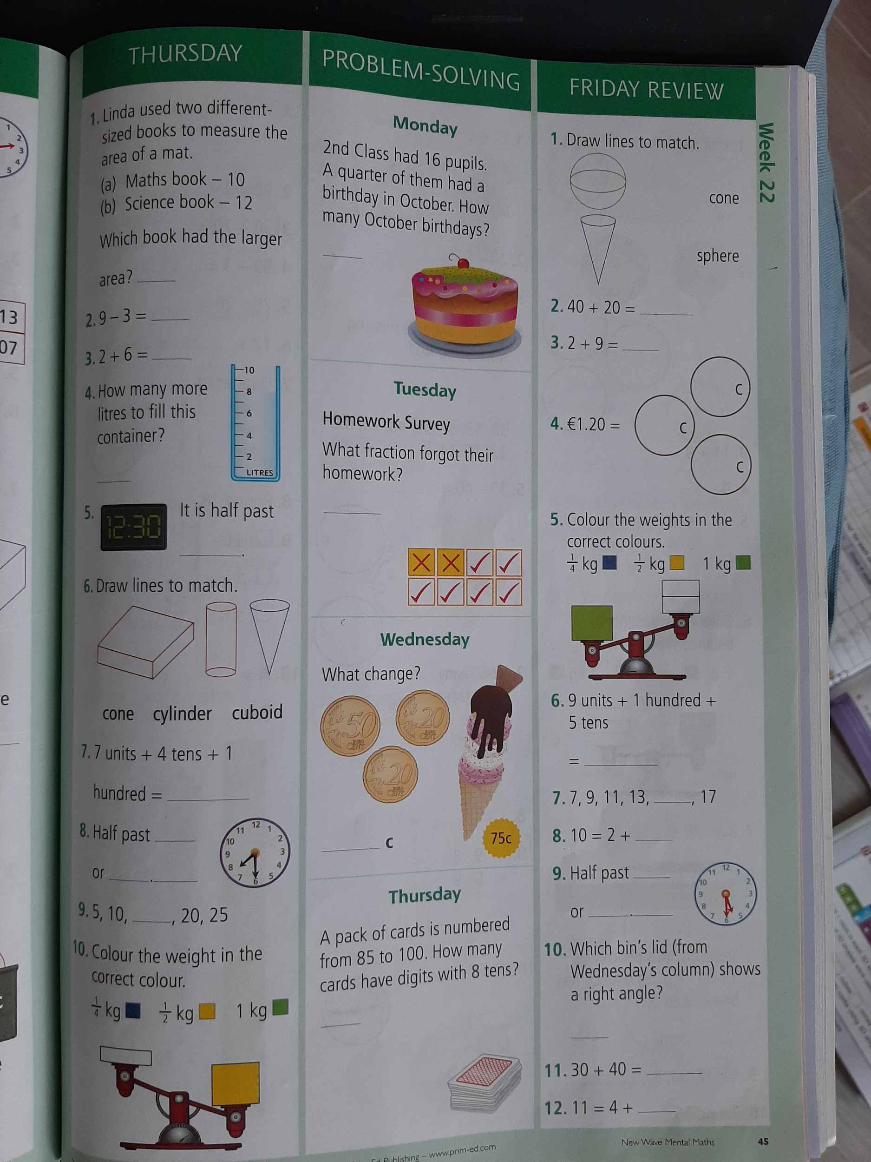

3. Art:

The month of May has arrived! May is the first month of Summer and we will begin to see many signs of Summer. Can you remember when the beekeeper came to our class? It was a fun day and we learned all about bees, wasps and honey. They are sure signs of Summer!
What do you think about when you think of summertime? Discuss this with someone at home.
Have you seen many bees so far this year? Here is a photograph of a bee that Amy found on her doorstep last week. He looked tired so I gave him some sugar and water.
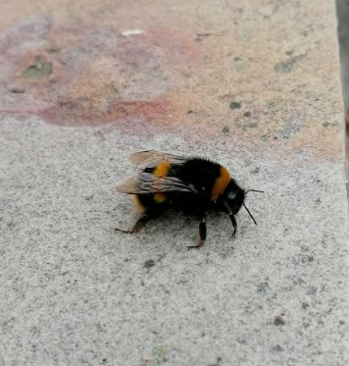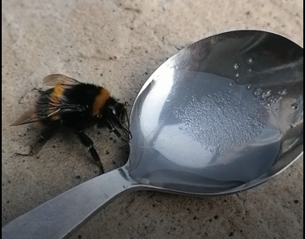
- Go back to the school website and click on the resource How to draw a honey bee. This will show you how to sketch a cute bee.
- You can add a summery background to your picture. Ask your parents if you can take a photograph of your creation and send them to us!

4. English:
Write a short story to go with the picture you have created.
-Start by introducing the main character.
- What/who are they? girl; boy
- What is their name?
- What do they look like? Tall; short; hairstyle; colour.
- What do they enjoy doing? Going for walks; going to school; cycling; playing football; cinema; shopping; watching TV; walking the dog.
Tell us a story about them. We’d love to see your work. Why not ask your parent’s permission to take a photo and send it to us!

Bonus activity: Caitríona will be hosting an assembly for you on Zoom today. Try to join in if you can - she would love to see you! If you can’t make it, you can still practise your sign language skills with Caitríona here.

