Monday:
Daily activities
​Spellings: Learn spellings daily and write 3 of the words in interesting sentences.
Writing: Set a timer for 5 minutes and do some "free writing" or "free typing" on a topic of your choice.
Reading: Try to read for at least 15 minutes (or more if you can)!
Maths: Daily 10 Mental Maths Questions. Try level 1 or 2.
· Skip counting in 4s to 40 (0, 4, 8, 12, 16, 20, 24, 28, 32, 36, 40)
· Weekly tables +7 (Find them here)
· https://www.topmarks.co.uk/maths-games/hit-the-button. Click the link, go to doubles and play doubles to 10. Have fun!
Here are your weekly spellings and tables:

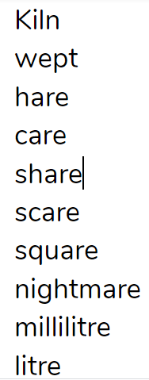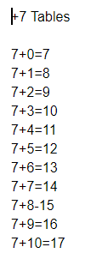

Monday:
1. Spellings:
This week most of your spellings “end in” <are> and make an /air/ sound.
- Write out these spellings: kiln, wept, hare, care
- Find and underline the <are> letter pattern (6 of the spellings have this pattern).
- Learn the first 4 spellings (kiln, wept, hare, care). Check out Anita’s video in Monday’s resources to help you.
*Challenge - can you think of any other words that have the /air/ sound? Use a dictionary or google to find out whether they are spelled with <are> or <air>.

2. English:
- What did you do over the weekend? Write your weekend news.
Remember the 5 Ws, Where? When? What? Who? Why?
You could also tell us how you felt while you did this activity. Did you enjoy it? Was it fun? Was it boring?
Watch the video titled Amy’s news in Monday’s resources to read and hear Amy’s weekend news. You can use this to guide you with your writing.
Remember to proofread (check over) your writing. You can use this checklist:
· Did you start every sentence with a capital letter?
· Did you end every sentence with a full stop?
· Did you put a finger space between each word?

3. Maths:
We are looking at money today. Can you think of the different coins up to 50c? There are 6 altogether!
· Write down the coins in your copy from 1c to 50c.
· Complete the worksheet on money. Use the coins that you have written down in your copy to help.
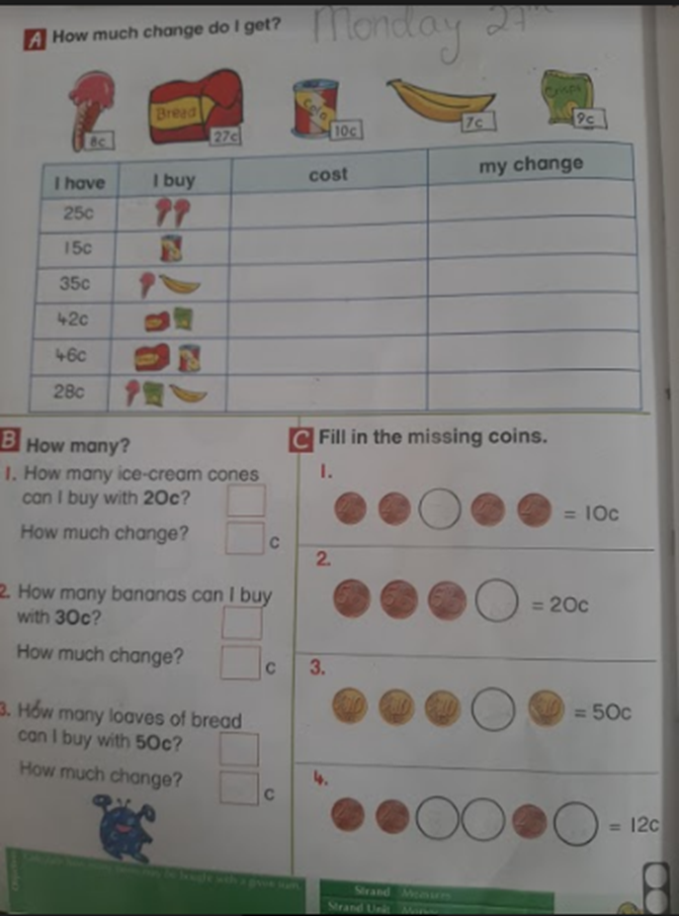
· *Challenge-Complete Monday on the problem solving worksheet below
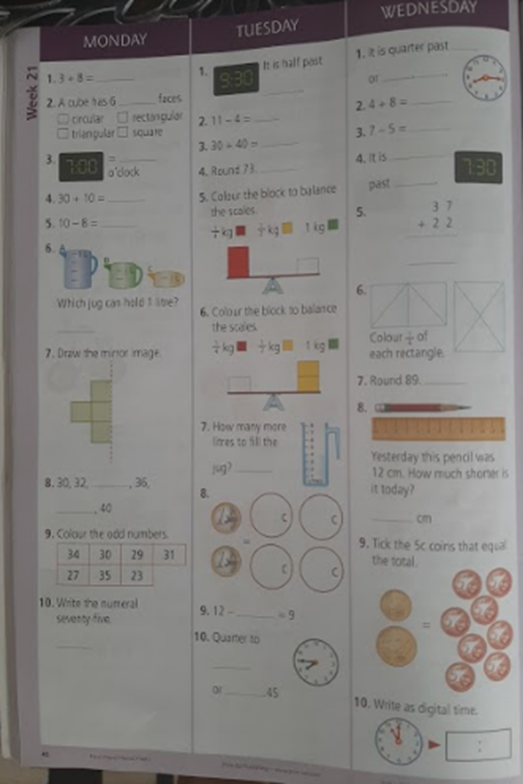
· 4. PE
· -30 high knees: These are fun - stand with your back straight and bring your knees up one at a time and count to 30.
·
· -10 push ups: Find a safe place on the floor and try to do 10, they are great for the muscles in our arms
·
· -30 shoulder press: Raise both hands in the air 30 times as fast as you can, its fun!
·
· -20 forward lunges: Step forward and make sure to keep your back straight, lunges are great for the muscles in our legs! Do you remember doing these in the sports hall?
·
· -20 squats: These are a really fun exercise for the muscles in our legs, you may remember these from our fitness circuit in the sports hall in school.

