Friday 22nd of May

Word families:Parents please give your children a spelling test and short dictation test based on this week’s word study. This week the spelling test is made up of words from the -ill and -ug word families. The children can use their phonological awareness to sound these words out. In the dictation the children have a chance to practice some or their tricky words. See sample below.
Spellings: hill, mill, pill, mug, tug, plug.
Dictation:
- The little hill is down here.
- Can you give me my mug?
- I live by the old mill.
Maths: Game time!
Here is a game about number order. https://www.tvokids.com/preschool/games/caterpillar-count
Here is a counting game that is fun!
https://www.themathsfactor.com/games/try/?gameid=46&prefix=ZONE&config=IPG_CM_Y1_CA_001,%20support&title=Count%20the%20Yeti%201%20to%2010
Give the Teddy some yummy cakes in this game! https://www.topmarks.co.uk/learning-to-count/teddy-numbers
Learn Together: Listen to Aisling read the story Ssshh We Have a Plan, on Seesaw.
Look at the picture from the story below and answer the questions. You can answer the questions by discussing them with somebody or writing your answers.
What are the four people thinking?
What is the bird thinking?
Do you see any items in the picture that are not very peaceful?
Draw your own picture showing the people and the birds living together peacefully.
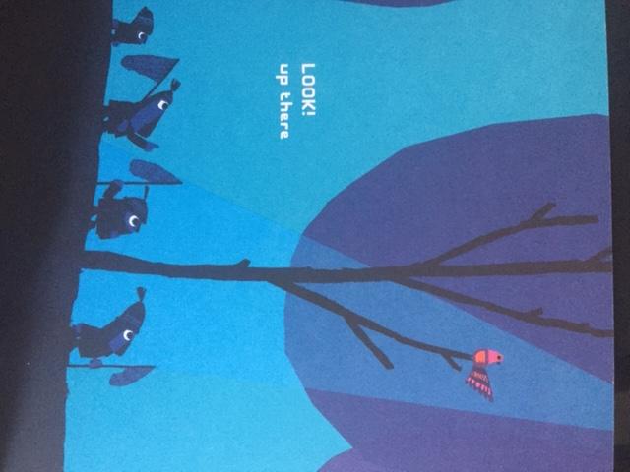

Mother Language Fortnight:
What are you thankful for today?

Well done on completing another week of Home Learning. Have a lovely weekend.

