Tuesday:
Daily activities
​Spellings: Learn spellings daily and write 3 of the words in interesting sentences.
Writing: Set a timer for 5 minutes and do some "free writing" or "free typing" on a topic of your choice.
Reading: Try to read for at least 15 minutes (or more if you can)!
Maths: Daily 10 Mental Maths Questions. Try level 1 or 2.
· Skip counting in 4s to 40 (0, 4, 8, 12, 16, 20, 24, 28, 32, 36, 40)
· Weekly tables +7 (Find them here)
· https://www.topmarks.co.uk/maths-games/hit-the-button. Click the link, go to doubles and play doubles to 10. Have fun!

1. English:
- Learn the next 3 spellings - share, scare, square
- Write each word in an interesting sentence. Check each sentence. Make sure that it makes sense and that you have a capital letter, finger spaces and full stops.
- Complete this worksheet. At the bottom there is a paragraph for you to proofread.
There are 9 missing capital letters, 6 missing full stops, 2 missing exclamation marks(!), 2 missing speech marks and 9 spelling mistakes and one missing word (in the 4th sentence). Can you spot all the mistakes?
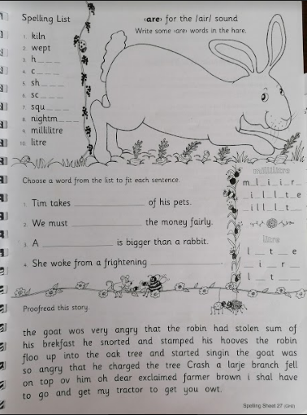

2. Maths:
- Lets look at money again today!
- Can you think of the coins that we used yesterday? Say them in your head, no need to write them down.
- Now imagine that you are going to the shop with a bag and will be buying fruit.
- Think of all that tasty, healthy fruit and how it looks.
- Complete the worksheet below. It selects different fruits and you have to work out how much they cost. It’s fun!
- The bottom part of the worksheet gives you 50c to spend and you can work out the cost of the fruit and how much change you get, enjoy!
*Challenge: Complete Tuesday on the maths challenge activity sheet below.

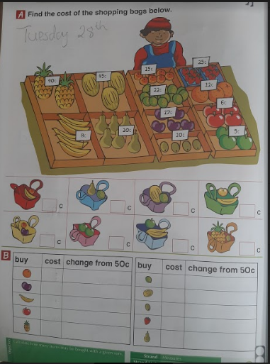

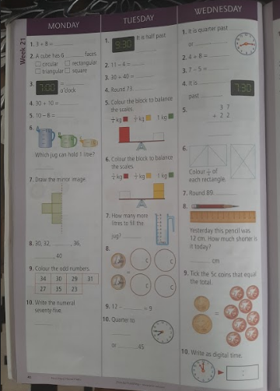

3.Science: We are going to look at the dandelion. I have seen lots of them around lately. Do you know what a dandelion is?
- Go to the list of resources on the main page a link to the life cycle of a dandelion. Think of places that you might find them.
- Write these questions and answer them on a page.
- How many stages are there in the lifecycle of a dandelion?
- How do dandelion seeds spread?
- What colours can a dandelion be?
- What happens to a dandelion at night time?
- What does the flower gradually turn into after 15 days?
I’d love to see your answers! Why not ask your parents for permission to take a picture of your writing and send it to me.

4. Gaeilge
Eist leis an ceacht ó Bua na Cainte You will find a link to a video from Bua na Cainte in Tuesday’s resources.
Then look at this activity page and write the sentences on a page.
